**1. PROJECT DESCRIPTION**

The project titled as “City Guide System“is a web based application. This software provides facility for searching for places in a particular area. Any Number of clients can connect to the server. Each user first makes their login to sever to show their availability. The server can be any Web Server. The server keeps the database record of the places with their information like contact numbers and nearest metro stations.

**Modules**

* Search module
* Coupons Genrator

**The Search Module includes,**

* Choice selection by the user. Here the user selects his area and the category he wants to search.
* Once the user clicks the search button, the database records are accessed and matching result is provided to the user.

**The Coupon generator module includes,**

* **Session Tracker:** It is a module which counts the number of sessions of a user.Every time the user logins, his session number is incremented in the database.
* **Generate Coupons:** If the user has crossed a certain number of sessions, the system will generate coupons for him. These are the electronic codes and can be used at different places.

**USER INTERFACE SCREEN SHOTS:**

**Home Page**

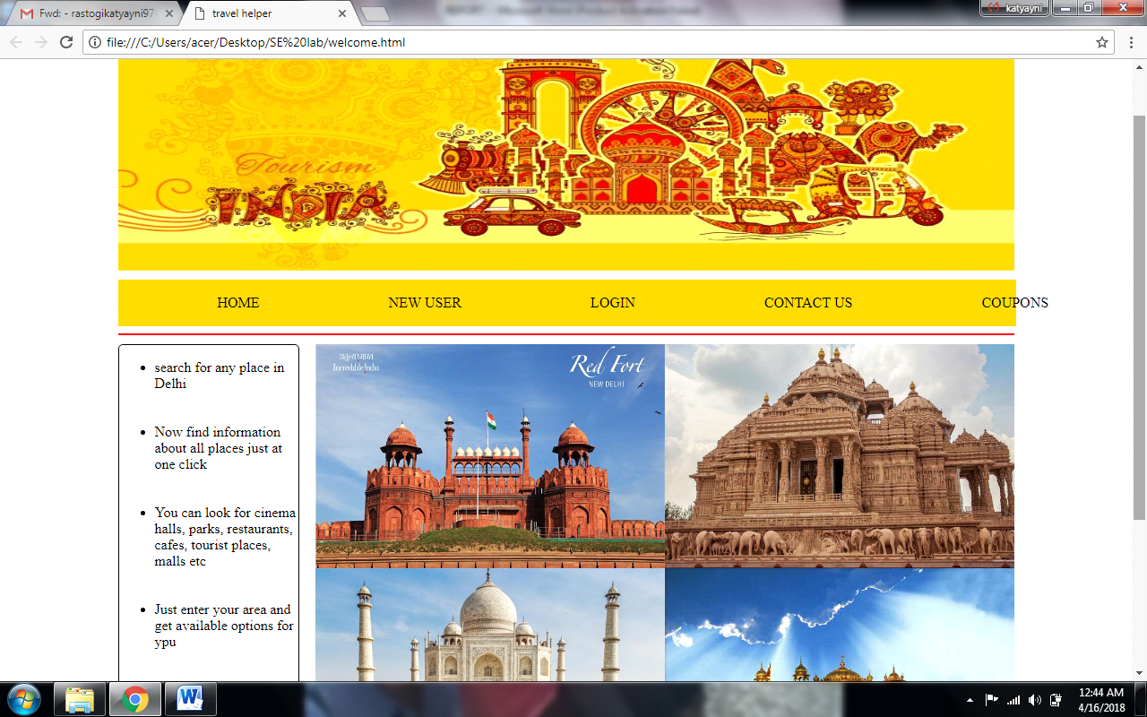

Registration Page

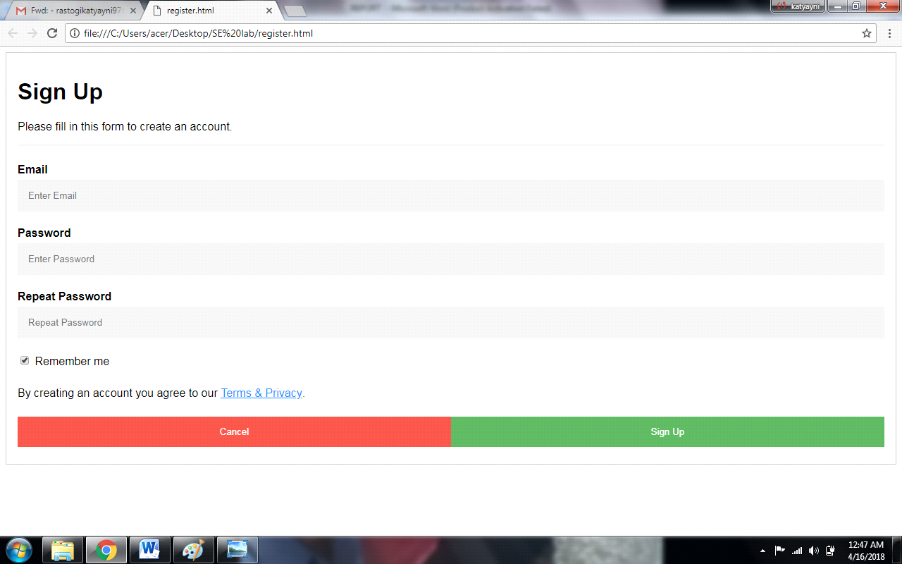

**Login**

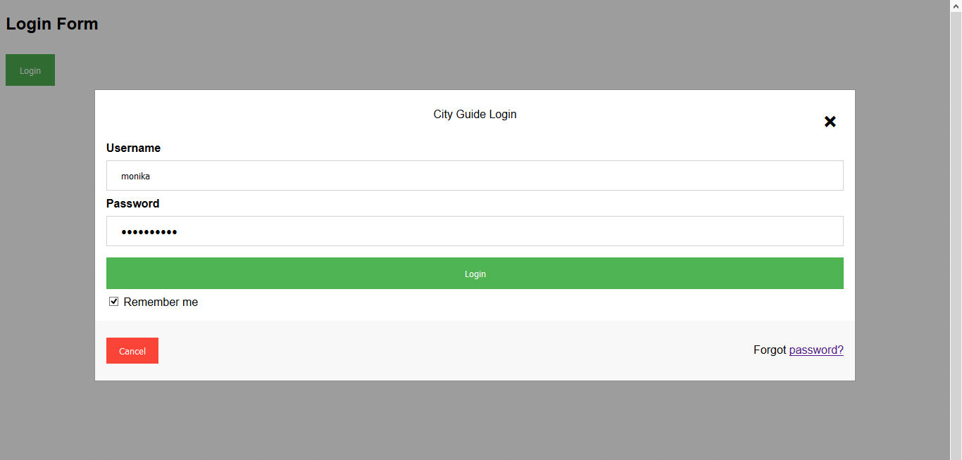

**Choice Selection**

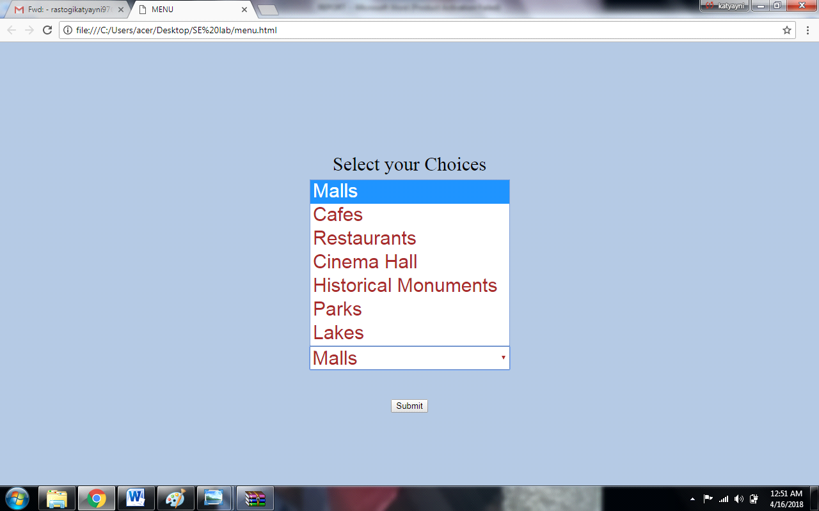

**Coupon Generation**

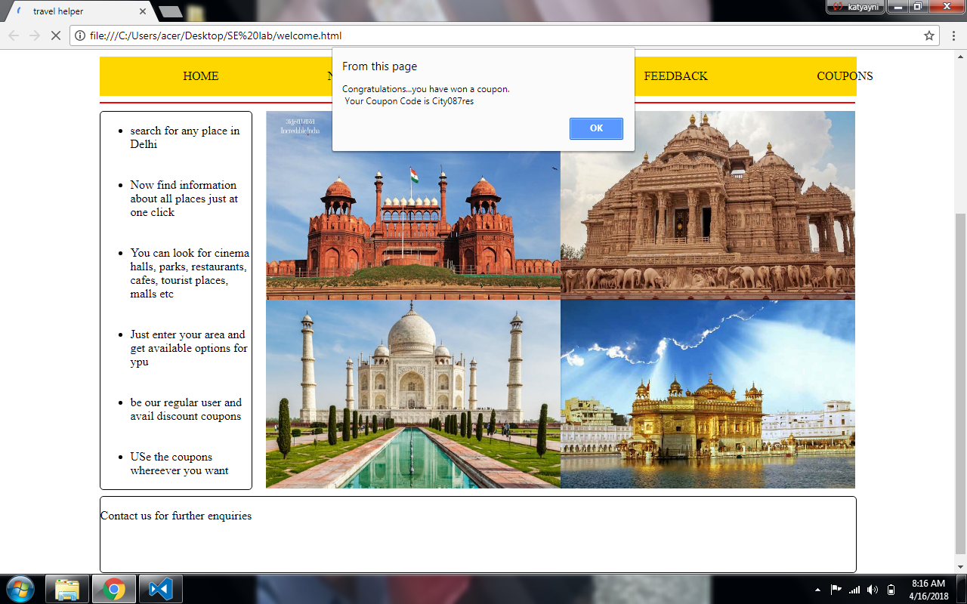

**Database Schema:**

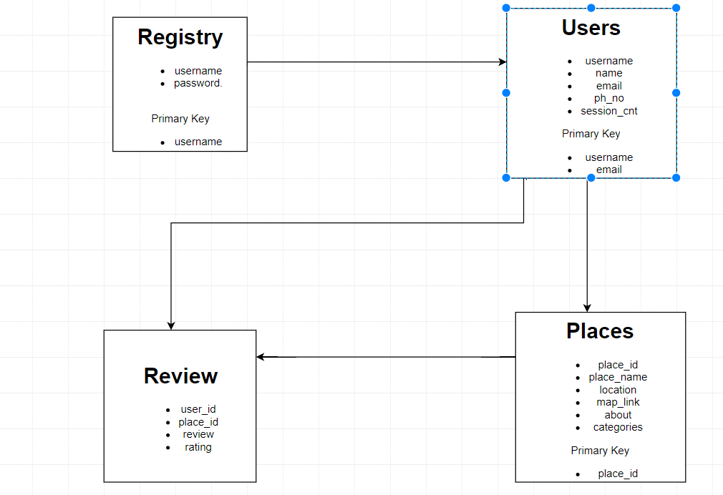

**Team Work Distribution:**

**Katyayni Rastogi :** Documentation, Use Case Diagram, Use case description tables, Activity Diagram and Sequence Diagram

**Manisha Malik:** Documentation, Class Diagram and Project Overview

**Kumar Archi Anand:**  Documentation, E-R Diagram and Data Flow Diagram

**Project Implementation:**

**Katyayni Rastogi :** Front-End, Client side Scripting and Content

**Manisha Malik:** Front-End and Content

**Kumar Archi Anand:** Back-End and Database